**Human Body Systems Project**

**Project Overview**

You will be assigned a body system or a specific function of a complicated body system to research and present. You will research facts about the body system using the Biology textbook and books provided in the classroom. You will only use the internet for pictures and diagrams for your handout/visual. You will use your notes to create a visual representation of the body system: poster, 3-D diagram, slide show, or stop-motion animation. Your overall goal will be to teach classmates about the body system, so they can complete a chart of all the body systems.

**Primary Learning Outcomes**

* Students will be able to name the human body systems and their functions.
* Students will be able to identify the organs and structural parts present in each system (i.e. circulatory: heart, arteries, veins, and capillaries).
* Students will be able to describe the basic structure of the major organs in each system. This includes types of tissues involved.
* Students will be able to link the functions of the body system to homeostasis
* Students will recognize different diseases associated with the body systems.

**Requirements**

**What to research for your assigned body system:**

* List and explain the functions of the organ system.
* Identify the major organs and their functions.
* Describe the basic structure of at least one major organ in the assigned body system. Include the type of tissues most common in the organs of this system
* Link the functions of the body system to homeostasis
* Describe a common disease associated with their body system.
  + Name of disease
  + Description of disease/mode of action (what malfunction does it cause)
  + Symptoms/Prevention

**Visual Aid:**

* Title
* Outline of body
* Diagram of major organs in anatomically correct locations
* Labels on major organs
* Neat, easy to understand, colorful, creative

**Presentation:**

* Present all required information (see above).
* Organized and easy to follow.
* All group members participate equally in the presentation.
* Spoken clearly and eye contact with audience

**Grading**

| **Research (Lab Grade)** | **Value** | **Your Score** |
| --- | --- | --- |
| List and explain the functions of the organ system. | 5 |  |
| Identify the major organs and their functions. | 5 |  |
| Describe the basic structure of at least one major organ in the assigned body system. Include the type of tissues most common in the organs of this system | 5 |  |
| Link the functions of the body system to homeostasis | 5 |  |
| Describe a common disease associated with their body system. Mode of Action | 5 |  |
| Describe a common disease associated with their body system. Symptoms | 5 |  |
| Describe a common disease associated with their body system. Prevention | 5 |  |

**The FIVE point rubric- for information on each category**

|  |  | Point Value |
| --- | --- | --- |
| **Content** | At least 3 facts/features listed | 3 points |
| **Accuracy** | Information is completely accurate and reflects a good understanding of the material. | 1 point |
| **Detail** | Notes give a full overview of the structures and functions | 1 point |

| **Visual (HW Grade)** | **Value** | **Your Score** |
| --- | --- | --- |
| Title- clear and bold | 1 |  |
| Outline of body | 1 |  |
| Diagram of major organs in anatomically correct locations | 5 |  |
| Labels on major organs | 5 |  |
| Neat | 1 |  |
| Easy to Understand | 1 |  |
| Colorful | 1 |  |
| Creative | 1 |  |

**Presentation**

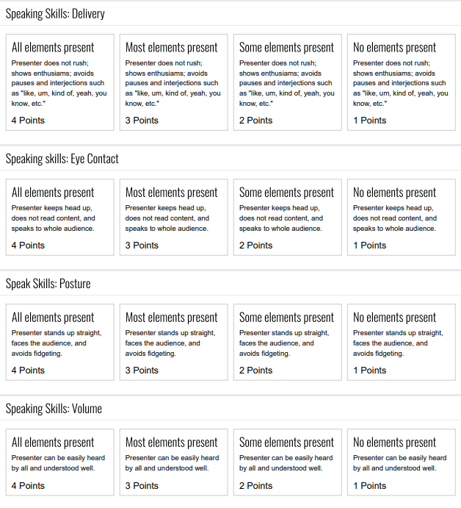

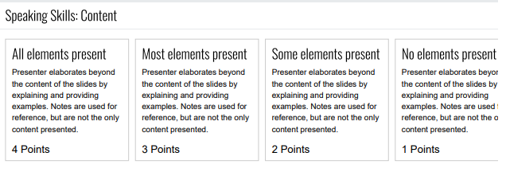

**Note Template**

-use the assigned book chapters to guide your notes

-you may use other books sources, but stick to the topics described in the textbook sections

| **System & Sections of Textbook** | Digestive System 29.1 & 29.2 |
| --- | --- |
| **Major Structures** | * **Salivary gland** * **Liver** * **Esophagus** * **Stomach** * **Pancreas** * **Large intestine** * **Small Intestine** * **Rectum** * **Mouth** |
| **Functions** | * The **Salivary gland** otherwise known as digestive glands. There are three of them and they make saliva and mix it with the food. * The **Liver** is the largest gland in the human body. Its importance is its capacity to produce bile. Blood contains toxic substances. * The **Esophagus** is a tube of muscles that connects the mouth to the stomach. * The **Stomach** is made of muscle which contracts churning the food inside. * The **Pancreas** produce enzymes that aid in breaking down fats, proteins and starches. * The **Large intestine** receives food that cannot be absorbed into the bloodstream and stores waste. * The majority of chemical digestions and absorption take place in the **Small Intestine**. * The **Rectum** is where excreted waste is stored and where it exits. * The **Mouth** functions both ingestion and the beginning of the digestive system. Your teeth and tongue are there for mechanical digestion. * The **Pharynx** is the upper portion of the throat. A cartilage flap covers the airway and prevents food from entering so you don't die.   Ingestion = Salivary Gland, Esophagus, Mouth, Pharynx  Digestion = Small Intestine, Stomach, Liver, Mouth  Absorption = Large Intestine  Nutrition = Pancreas  Elimination = Large intestine, Rectum |
| **Homeostasis** | The body maintains homeostasis by ingesting nutrients into your body. When you are doing the process of elimination, you excrete waste which helps maintain water and salt balance when you are pooping. |
| **Tissues** | The intestines have smooth muscle and epithelial tissue lining the inside. The smooth muscle helps push the food through the stomach and your intestines. The epithelial tissues coat everything inside the digestive system. |
| **Disease** | Lactose Intolerant |
| **Other Facts** | The Stomach has many parts to it and you produce a lot of saliva. |
| **Other Sources Used** |  |